Aleksy Ruszała

# Login

To log in to the system enter open the web browser then enter the appropriate URL. When the page loads, enter the appropriate password and press the "login" button. After entering the correct password, you will be taken to the main page.

# Display the list of club members

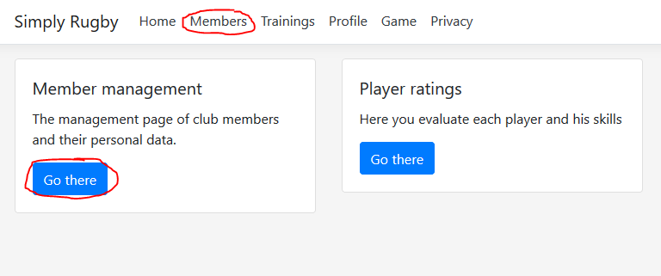

To display the list of club members, select the Members tab in the menu or on the main page, find the "Member management" window and press the "Go there" button and then you will be taken to the page.

# Add new member

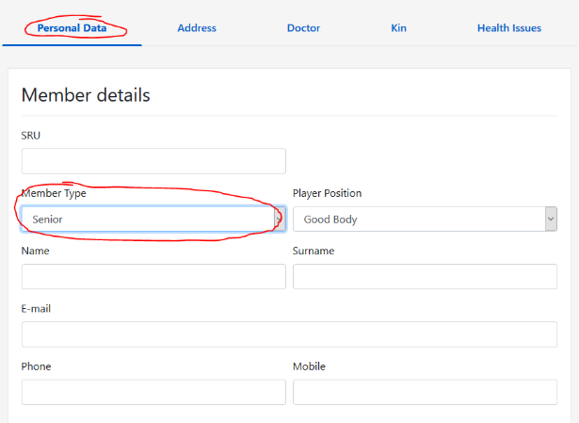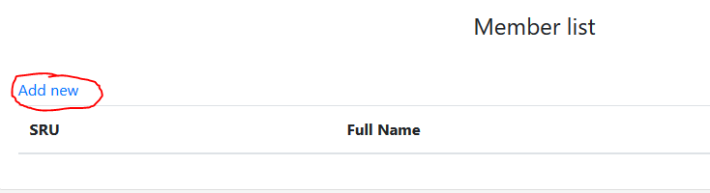To add a new member, go to the "Member" page earlier. Above the list of members there is a "Add new" link, press it and you will be transferred to the form. Depending on the type of member, select the appropriate "Member Type" and fill in all the required data for the member, his SRU ID, personal data, address etc. The data is categorized in tabs. To go to the appropriate tab, simply click on its name. Tabs appear or disappear depending on the type of member. Once you have filled out all the data, confirm it with the "submit" button. If the data entered does not comply with the requirements, you will be informed by red guidelines. Data should then be corrected and confirmed again. 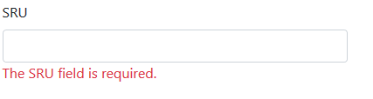

To add "Health Issues" or "Guardians", press the "Add" button in the appropriate tab and complete the form that will show up in separate window and confirm the changes.

After approval, the data will be added to table. You can edit  and delete them using the appropriate icons. You can cancel any change at any time by pressing "Cancel" or closing the browser window.

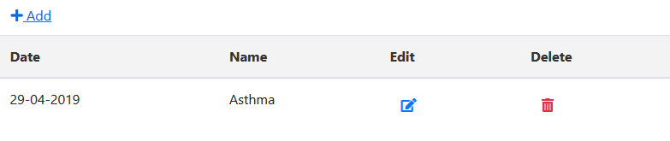

# Editing an existing member

To edit a member, go to the "Member" page earlier. Find the selected member in the table with the users and select the "edit" button next to the selected entry. At this point, you will open a form with the current membership details. You can now edit the selected data and save it after pressing the "Submit" button. The editing procedure is compacted to add a new member. To add more detailed information, see how to add a new member.

note: at this stage it is not possible to change the member type if currently a member is a player and his data has been used in other sections of the page such as Training or Profile. To do this you must delete all relations related to this member before attempting to change its type.

# Delete member

To delete a member, go to the "Member" page earlier. Simply select a user from the list and press the "delete" button next to his entry

note: at this stage it is not possible to delete the member if currently a member and his data has been used in other sections of the page such as Training or Profile. To do this you must delete all relations related to this member before attempting to change its type.

# Display member details

To see a member details, go to the "Member" page earlier. Simply select a user from the list and press the "details" button next to his entry

# Evaluating players

To assess players, select the "Profiles" section from the menu or from the main page chose “Player ratings”. The list of players will be displayed. Select a player from the list and press the "Evaluate" button. You will go to the website where you can see a list of available categories along with skills that you can assess.



With each skill you have the option of evaluating it from 1 to 5 and the box next to entering an additional note.

tip: if there are no skills on the site, go to the "Profile" page and press the "Add Categories / Skills" button to add them. More information in the Add/Edit or Delete Categories / Skills section.

# Add/Edit or Delete Categories / Skills

To manage your skills and their categories, you must first go to the "Profiles" section and press the "Add Categories / Skills" button located above the table with players.

A page with a table should appear, all available categories and abilities are in it. Just to add a new category, press the "Add" button located above the table and complete the form. Removal and editing is done by pressing the Edit or Delete button on the skill list.

note: by removing the skills from the list you also delete all information associated with them, i.e. all trainers' assessments assigned to them.

# Trainings list

To display the training history, go to the "Trainings" section by choosing it from the main menu or from the main page.

# Add new Trainings

To add new training, you must first go to the " Trainings " section and press the "Add new" button located above the table with trainings.

When the form appears, fill it in with appropriate data such as date, location and select a trainer from the list of club members. The coach by definition may be any non-player member.

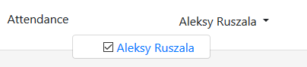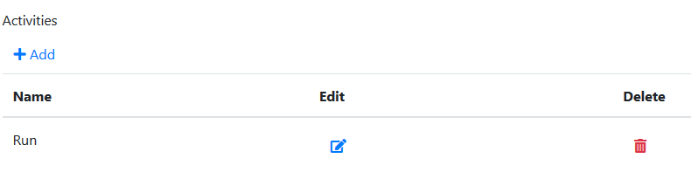In addition to the Activities table, you can add all exercises that have been carried out. You can add, edit and delete them before you can add a new workout entry. Additionally, in the Attendance section, you can select all players who were present during these classes.

Do not worry all the data can be changed after saving or to abandon changes press "cancel".

# Edit Trainings details

To add new training, you must first go to the " Trainings ". Select the training from the list and press Edit.

The process of editing the training is very similar to adding new training (Check for more information in Add new Training). all data about current training is entered in the form that will allow you to edit them. After finishing the changes, press the "submit" or "cancel" button to change the changes.

# Delete Training

To delete training, you must first go to the " Trainings ". Select the training from the list and press delete button.

# Display Training details

To see training details, you must first go to the " Trainings ". Select the training from the list and press details button.

# Game history list

To display the training history, go to the "Game" section by choosing it from the main menu.

# Add new Game

To add new game, you must first go to the " Game " section and press the "Add" button located above the table with games. Adding matches has been divided into two occasions. In the first there are general data about the game, in the second we have the opportunity to add each scored point by both teams. To do this, simply press the add button above the table and fill in another form in a new window that appears. After filling in the correct form data, the game will be saved in the system.

# Edit Game

To add new game, you must first go to the " Game " section and press edit button next to chosen game from list. Editing is like adding a new game (see Add new Game). All data can be freely edited and saved.

# Delete Game

To delete game, you must first go to the " Game " section. Select the game from the list and press delete button.

# Display Game details

To see game details, you must first go to the " Game " section. Select the game from the list and press details button.